Contents Page
Comments page 2
Introduction 3
Main information/ 6
Experimental Methods
Conclusions 11
Materials 12
Acknowledgments 16
References 17

Comments Page
We invite you to read our project and we hope you enjoy and learn from the activities we have completed.
_______________________________________________________________________________________________________________________________________________________________________________________________________________________________________________________________________________________________________________________________________________________________________________________________________________________________________________________________________

Signed: ________________

Introduction

Cian, Faela and I (Matthew) were preparing to cook scones in the kitchen as a treat for our friends who were coming to tea later. I got out all the ingredients we needed, flour, salt, sugar, butter, raisins eggs and milk.
Cian loves cooking and he had already cooked a chicken curry and pasta bake for later on. Cian had not tidied away his ingredient when I started to prepare for making the scones.
Cian came back into the kitchen quickly and accidently mixed the raisins with the flour. Then to make matters worse Faela came out of her room holding a big bowl of paperclips yelling, “I did it! I made a house of paperclips, she slipped on some flour and the bowl of paperclips went flying into the flour mixture too. (Faela prefers experimenting than cooking) Cian and I got a shock and dropped what we holding and suddenly all the ingredients on the worktop seemed to have changed places and ended up where they didn’t belong. The three of us were standing staring at the mess before us. What were we to do? We needed the different ingredients in separate bowls so we could put in the right amount into the scone mixture.

We found:
- pasta, salt and rice in one dish.
- Flour, raisins, paper clips in another.
- water and cornflour in another container.
- The butter slipped into a bowl of boiling water.
- The salt fell into more water in a silver bowl.
- The sugar I had weighed out was slowly pouring itself off the counter into a large container of fresh water.
What were we to do? If we wanted to make scones we had to take action!

Objective:
We had intended making scones but at this stage we decided that time wasn’t a factor so we set about separating the various mixtures as we needed the main ingredients separated to make the scone mixture properly. We needed to separate the other ingredients also so that we could cook other dishes again. This was our immediate task so we started to try and work it out.
Prediction:
We began to discuss the problem and asked whether it was possible to separate the ingredients. We all decided that it must be possible to separate the mixtures of solid ingredients using kitchen utensils.
The three of us felt it would be very difficult to separate the liquids and solids and the butter and water. We decided to try anyway
Main Information
This is how we went about separating the various mixtures. We had a discussion about each one and tried the following.
Mixture 1: Solids (flour/raisins/ paper clips)
We chose a colander, sieve and a fridge magnet to help us separate these and it worked.
First you get the sieve and shake the flour out of it into a clean bowl then you get the fridge magnets and draw the paper clips out as they are magnetic. At least we had these separated again.
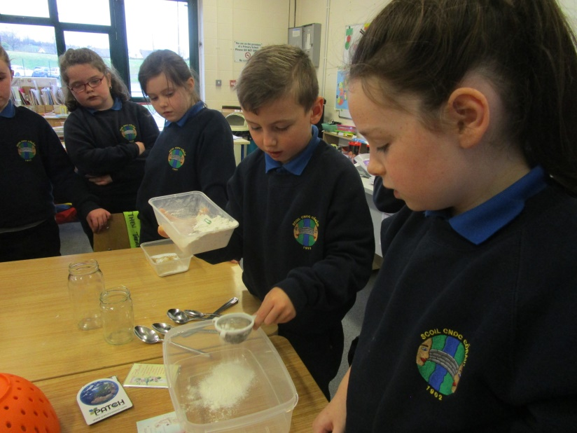

Mixture 2: Separating (water/cornflour).
This seemed an impossible task after much talk we noticed that the cornflour had fallen to the bottom of the jar. This seemed to set us thinking and I (Cian) came up with idea that we should strain off the water into a bowl through a kitchen cloth. Amazing it worked. Now we had taken most of the water out of the mixture. All was left was a semi-solid white mixture. Matthew thought that if we left the wet mixture sitting on the radiator for a while it might dry it out. Yes bingo! We had our cornflour dry again.
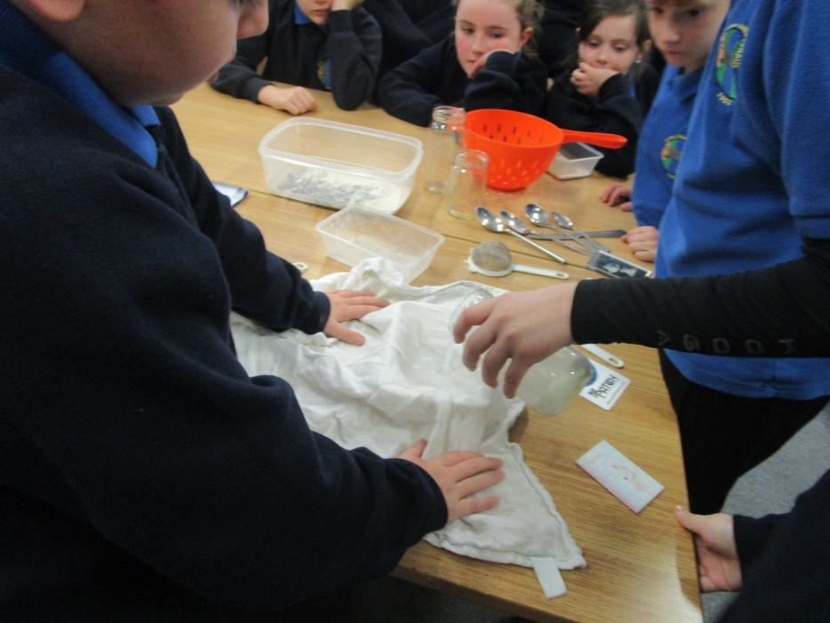
Mixture 3 (Rice/Pasta/Salt)
Faela decided that by using some kitchen utensils this task was possible. She poured the mixture through a colander first and separated the pasta. Then it seemed easy enough. Cian then separated the salt from the rice by putting the mixture through a sieve. Great! We now had the salt we needed for our scone mixture.
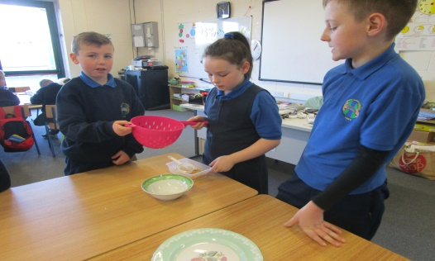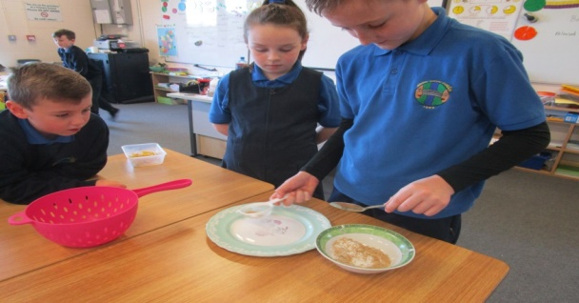
Mixture 4 & 5: (sugar/water) (salt/water)
How was this possible? The sugar or the salt could not be seen any more because they had dissolved into the water. We decided that both of these mixtures would probably require the same action. After a lot of discussion again Faela had heard someone talking about how the sun dries up water. Matthew suddenly thought if we dried out the water over night we might end up with sugar and salt in separate bowls again. We poured each mixture into separate flat plates and left them on the radiator to dry off. Again success we had enough salt and sugar to continue making the scones.

Mixture 6: (butter/hot water)
This was a task that seemed very difficult. Again while we were discussing how to go about it, Cian noticed that the butter seemed to be settling at the top of the liquid. We thought with everything going our way this might too. Click! Together we thought let the mixture cool completely. To help it along we put it in the fridge. We were very pleased to see we could now separate the two as the butter was now semi-solid. We lifted out the butter with a straining spoon. The butter was semi-solid and not perfect but we only needed a small amount and we felt it would do. Now we finally had everything we needed to make the scones even if was a couple of days later.

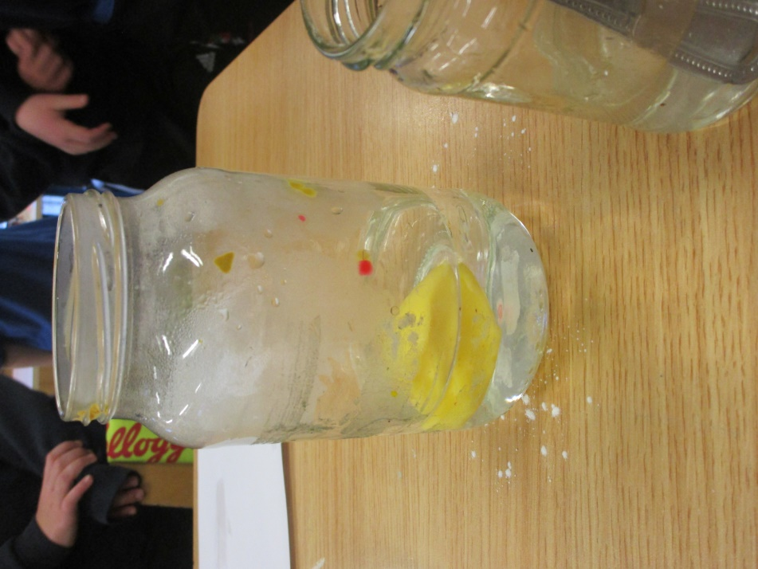

Conclusion
After all the excitement of chaos in the kitchen the three of us decided to reflect on what had happened. We are all interested in science and through these activities we learned that sometimes you might find it hard to find a solution to a problem but if you keep trying it might work out.
We also learned that it is possible to separate solid ingredients from each other using the right kitchen equipment.
During our activities we also learned that evaporation can be a solution to separating liquids from solids that have dissolved in them.
Another fact we learned is that butter when it is melted is lighter than water as it floats to the surface of the water.

Materials
Materials can be sorted into three different groups: solids, liquids and gases
Liquids
A liquid is something you can pour. A liquid will fill the shape of its container.
There are many liquids such as water, washing up liquid, fizzy drinks, orange juice, milk and alcohol.
When frozen water turns to ice.
The ocean is filled with liquid called water.
People can drink some liquids such as milk, water, fizzy drinks, orange juice and alcohol.
We use other liquids such as petrol and oil in machinery.
Some liquids are used for cleaning like washing up liquid or bleach.

Solids
A solid is visible and has a shape of its own. Last year in science we were working on sorting materials and we grouped a selection of solid materials into different groups. We grouped them into the following five according to what they were made of: wood, metal, glass, paper and plastic.
Many solid materials are used to construct other things like buildings, clothes, cups and so on. There is a huge amount of solid materials available in the world.
We also learned that solid materials can be natural like wood or rubber. These are natural as they are formed by nature. We use them to make many other things.
Solid materials can also be man-made like plastic or nylon. These are created by man using natural or other man-made materials.

Gases
A gas is usually invisible and usually has no shape of its own. Gases can have strong smells or no odour at all.
We have learnt that there are many different gases. There is gas in a lot of things. We learnt that there is gas in fuel.
Many gases are used every day in work places and in the home for cooking or running other machines.
Gases are very useful but they can be dangerous. Did you know that there are poisonous gases too? You can find it in slurry pits. This gas can knock you out if you breathe it in. So not all gases are good!!! We must tell someone if we get a strong smell of gas especially in towns or cities where gas is used to heat houses. Gas can light easily and cause a lot of damage.

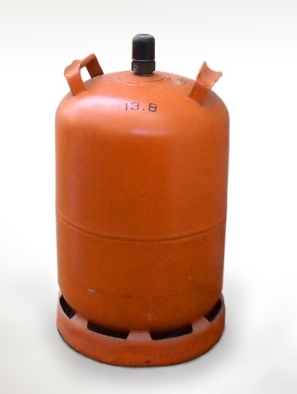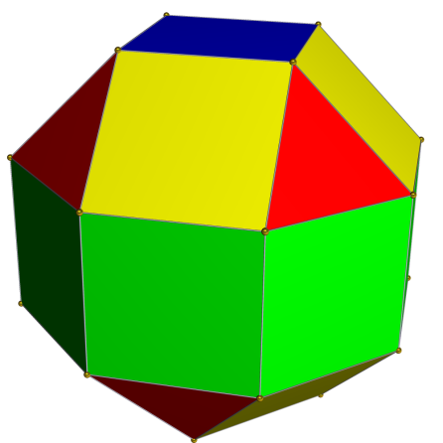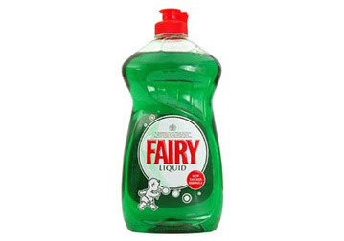
Gas Solid Liquid

Written and researched by Faela, Cian and Matthew

Acknowledgements
We would like to thank these people for helping us do our wonderful display today.

Our teacher Mrs. Boyle and our SNA Mrs. Douglas, our parents and of course ourselves: Matthew, Cian and Faela.

We would like the two judges to be inspired by this project that we have been working on over the last while. We are all very interested in science and love a challenge.

(Thank you all)

References
www.twinkl.co.uk

Earthlinks Third Class Folens
Earthlinks Fourth Class Folens
Unlocking SESE 3rd Class Folens

Small World Geography and Science Third Class CJ Fallon

