U.S.A Bridges
Verrazano-Narrows Bridge
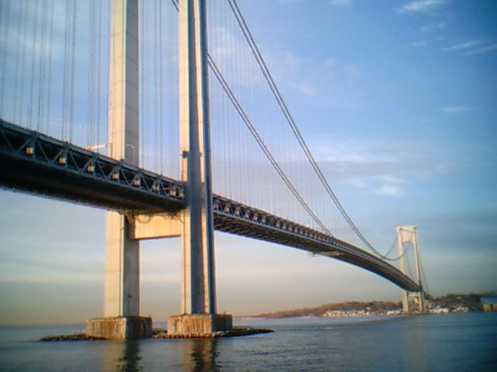
Golden Gate Bridge
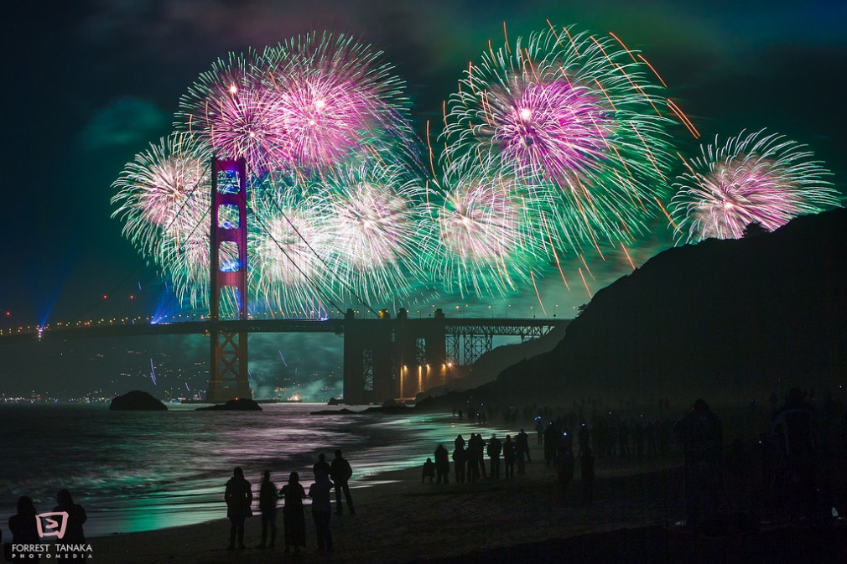

These are very famous attractions in the U.S.A
Republic Of Ireland Bridges
Mary Mc Aleese Bridge
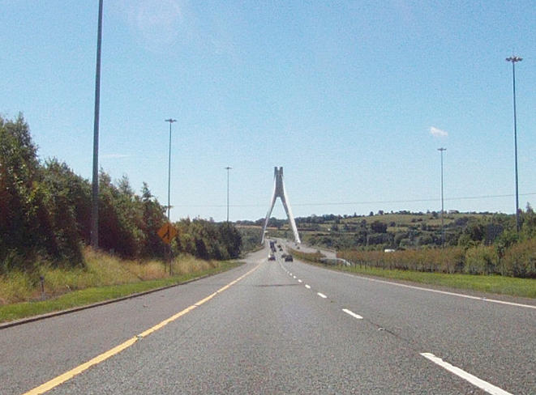
Liffey Bridge
