Contents Page
Project Registration Form
Comments page 2
Introduction 3
Main information 6
Experimental methods 7
Conclusions 10
Heat 12
Temperature 13
Acknowledgements 14
References 15

Comments Page
Thank you for reading our project. We will be glad to read your comments and take on board any suggestions you make.
________________________________________________________________________________________________________________________________________________________________________________________________________________________________________________________________________________________________________________________________________________________________________________________________________________________________________________________________________________________________________________________________________________________________________________________________________________________________________________________________________________________________________________________________________________
Signed ___________________
Introduction
We are three archaeologists from Knockconan NS. We were heading off on a dig to the bog. We realised that we needed some hot water to wash our hands before we ate our meal after three hours of work. We felt it would be nice to wash our hands in warm water as it would be more comfortable than very cold water.
We had limited resources where we were staying and found it hard to find suitable containers to hold hot water. Below is a list of the containers we found and thought suitable.
- An old hot water bottle with a screw cap.
- An old children’s flask with cap
- A pyrex glass cup
- A paper coffee cup with lid
- A clay pot
- A plastic liquid container with a lid

These would all hold water but would they be suitable for our needs. That left us with a problem to solve.
Objective:
The objective of the task on hand was to find the most suitable container that would hold water hot long enough at a temperature suitable for washing our hands.
Step 1:
We found that body temperature is 37degrees centigrade. With this in mind we wanted the water to remain at a temperature below this so that would not burn our skin.
Step 2
We decided to do a test and measure the temperature of the hot water we put in each container over a three hour period to see which container would hold the heat the longest and then we would decide which container to take on this trip.

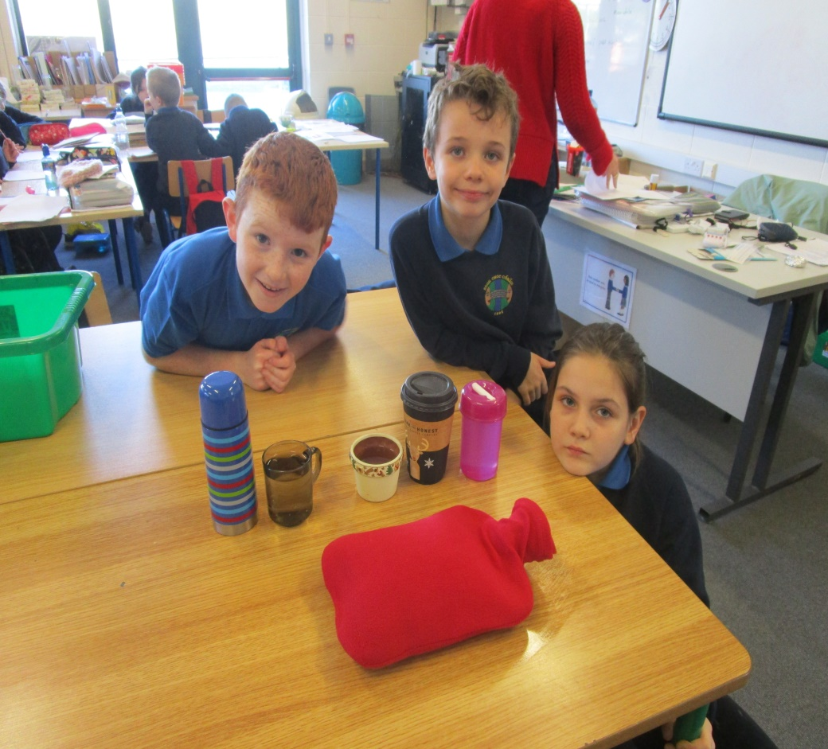

Main Information
(This activity involved using boiling water. We got our teacher to pour in the water for us. We wanted to remain safe and not get burnt. We only handled the water when it was cool enough to do so)
(We have included the record of temperatures for each container towards the end of the project).
We selected two containers each from the collection listed previously to work with.
Shauna chose the clay pot and an old hot water bottle.
Conor chose an old flask and a paper coffee cup.
Cathal chose a glass cup and the plastic liquid bottle.

Experimental methods
Test 1:
For this test we decided to put only 200ml of boiling water in each container.
We boiled the kettle to boiling point as we understood it to be. Using a measuring jug we poured 200ml of water into each container and recorded the temperature of each. We made sure each container had a lid on or a cover of some sort. We thought if all the containers had the same amount of liquid and a lid on it would be a fair test. We checked the temperature every hour over three hours and recorded it for each container.
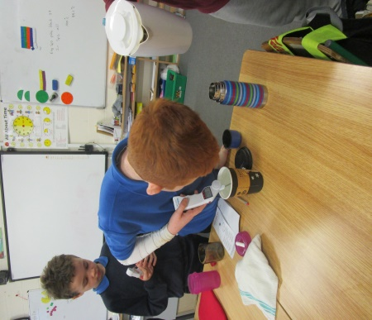

Test 2:
This time we filled the containers to the very top. We thought it would be a fair test if we did the same for each container. Again we checked the temperature every hour over three hours and recorded it for each container.
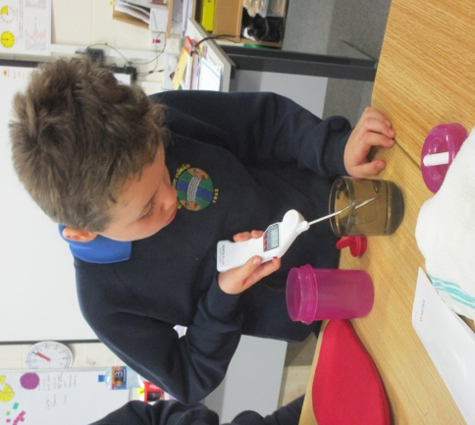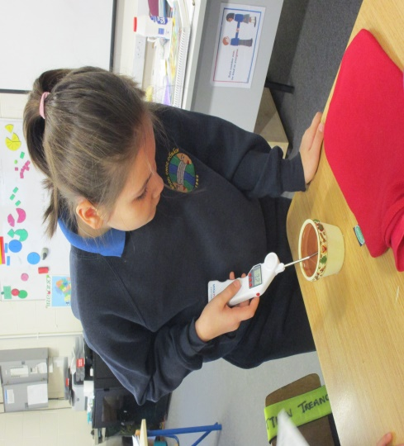
Prediction for first test:
Before we started our first test we each predicted which container would hold the heat the longest.
My Prediction (Cathal) was the hot water bottle because I use one at home and I always find it is still a bit warm after the night.
Conor predicted that the paper coffee cup would hold the heat the longest because his experience showed him that a coffee cup can keep liquid warm for a long time.
Shauna picked the hot water bottle also for the same reason as me.
Second Test:
Our second Prediction was that Conor predicted the flask Shauna predicted the flask and I (Cathal) predicted the flask too. We decided on this because the flask held the temperature the hottest for longest in the first test.

See records of temperatures on following pages

Conclusion
When we had finished recording the temperatures we looked at the results and discussed which container would be most suitable for our trip and which would do the job we wanted that is keep water hot long enough so that it would be pleasant for washing our hands on an archaeological dig.
We decided that the flask or the hot water bottle would be the best containers to take with us. Both lost heat over the three hours in both tests but they were both still at a nice temperature for hand washing.
The other containers lost heat quickly and soon became too cold. Also the flask and the hot water bottle both had tight lids which we felt was important for carrying water.

This project was very enjoyable and we were very active in our class when we were doing it. We learned to measure temperature with a thermometer. We also worked as a team and shared out the work.
Over the project we learned other knowledge about heat. There are some pages of information in the book for you to read and gain more knowledge.
In addition to taking the temperature of the hot water we also took the temperature in various parts of the school between 9.15 and 9.30 on 21st November. We found small variations in the different places on that particular day. We have included the results in the booklet also.

Heat
The sun is a star. It is the nearest star to earth. The sun is like lava and fire but very, very, very hot. The sun is our greatest source of heat. The sun gives us heat and light. The sun is in the middle of the atmosphere.

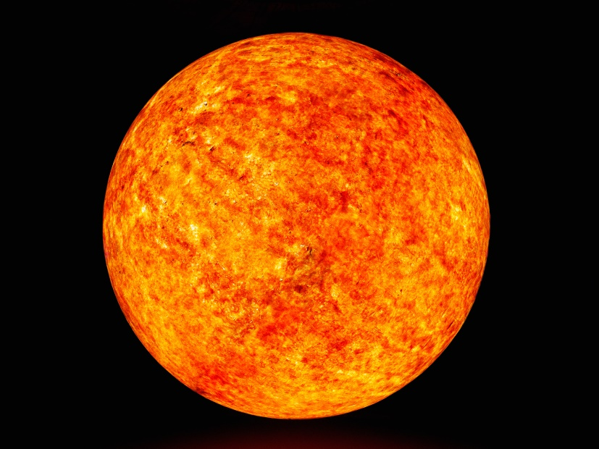

Temperature
Temperature is the measure of how hot something is. We measure temperature with a thermometer. During science we learned to take the temperature of water with a digital thermometer. We measured temperature in degrees centigrade.
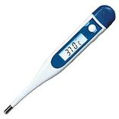

Acknowledgements
Thank you to Mrs Boyle our teacher, Mrs Douglas our SNA for their encouragement and help during the project.
Special thanks to Shane and Annette, Linda and Darren, Janice and Barry our parents for helping us with this science activity.
We were delighted to take part in this activity. We learned much and we hope that others will learn from our work too.
We have offer special thanks to our principal Ms. Brennan who encouraged the school to take part in this challenging activity.

References
www.twinkl.co.uk

Earthlinks Third Class Folens
Earthlinks Fourth Class Folens
Unlocking SESE 3rd Class Folens

Small World Geography and Science Third Class CJ Fallon

