Design and Make Traffic Lights

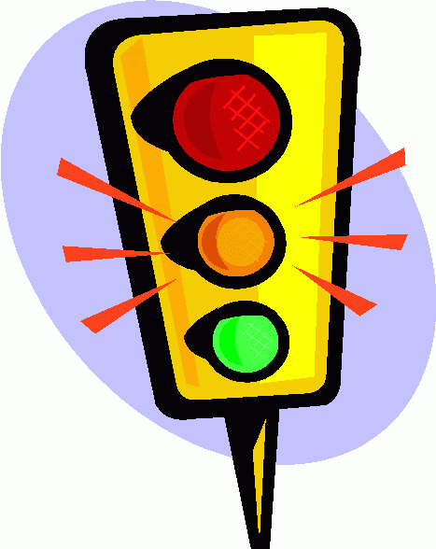
What you need?
- An old tissue box.
- Red, orange and green tissue paper.
- Sellotape or glue.
- Torch.
Activity
- Cut out three circles approximately 6 cm in diameter, at equal intervals vertically and in line on the base of the tissue box.
- Paint the box black if you wish or cover it with black paper.
- Cover each hole with tissue paper in the correct order as they appear on real traffic lights. Secure the tissue paper with glue or sellotape.
- Shine a torch through the back of the box at each colour.
- Observe what happens.
By: Colin and Noah

